**Project Planning Phase**

**Project Planning Template (Product Backlog, Sprint Planning, Stories, Story points)**

|  |  |
| --- | --- |
| Date | 14 April 2025 |
| Team ID | SWTID1743517551 |
| Project Name | HouseRent |
| Maximum Marks | 5 Marks |

**Product Backlog, Sprint Schedule, and Estimation (4 Marks)**

Use the below template to create product backlog and sprint schedule

| **Sprint** | **Functional Requirement (Epic)** | **User Story Number** | **User Story / Task** | **Story Points** | **Priority** | **Team Members** |
| --- | --- | --- | --- | --- | --- | --- |
| Sprint-1 | User Authentication | USN-1 | As a user, I can register and log in to the application using email & password. | 2 | High | Aditi, Nitya |
| Sprint-1 | Property Listing | USN-2 | As a landlord, I can list my property with details and images. | 3 | High | Samradhi,Aditi |
| Sprint-2 | Admin Control | USN-3 | As an admin, I can approve or reject property listings. | 2 | Medium | Ruturaj,Nitya |
| Sprint-2 | Dashboard | USN-4 | As a user, I can view a dashboard showing relevant property listings and my interactions. | 3 | High | Samradhi, Nitya |
| Sprint-3 | Property Filtering | USN-5 | As a user, I can filter properties based on location, rent, and availability. | 2 | Medium | Aditi,Ruturaj |
| Sprint-3 | JWT Authentication | USN-6 | As a user, I can securely log in using JWT so that my session remains authenticated. | 2 | High | Samradhi,Ruturaj |
| Sprint-4 | Role-Based Dashboard | USN-7 | As a user/admin/landlord, I can see a personalized dashboard depending on my role. | 3 | High | Samradhi,Ruturaj,Nitya,Aditi |

**Project Tracker, Velocity & Burndown Chart: (4 Marks)**

| **Sprint** | **Total Story Points** | **Duration** | **Sprint Start Date** | **Sprint End Date (Planned)** | **Story Points Completed (as on Planned End Date)** | **Sprint Release Date (Actual)** |
| --- | --- | --- | --- | --- | --- | --- |
| Sprint-1 | 20 | 2 Days | 3 April 2025 | 5 April 2025 | 13 | 5 April 2025 |
| Sprint-2 | 20 | 1 Days | 6 April 2025 | 7 April 2025 | 7 | 7 April 2025 |
| Sprint-3 | 20 | 2 Days | 8 April 2025 | 9 April 2025 | 4 | 9 April 2025 |
| Sprint-4 | 20 | 3 Days | 10 April 2025 | 12 April 2025 | 8 | 12 April 2025 |

**Velocity:**

Imagine we have a 10-day sprint duration, and the velocity of the team is 20 (points per sprint). Let’s calculate the team’s average velocity (AV) per iteration unit (story points per day)

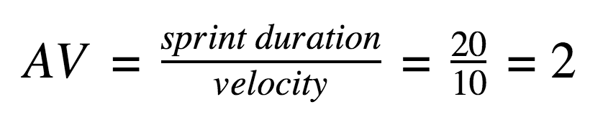

AV=32/8=4

**Burndown Chart:**

A burn down chart is a graphical representation of work left to do versus time. It is often used in agile[software development](https://www.visual-paradigm.com/scrum/what-is-agile-software-development/) methodologies such as [Scrum](https://www.visual-paradigm.com/scrum/scrum-in-3-minutes/). However, burn down charts can be applied to any project containing measurable progress over time.

[**https://www.visual-paradigm.com/scrum/scrum-burndown-chart/**](https://www.visual-paradigm.com/scrum/scrum-burndown-chart/)

[**https://www.atlassian.com/agile/tutorials/burndown-charts**](https://www.atlassian.com/agile/tutorials/burndown-charts)

**Reference:**

[**https://www.atlassian.com/agile/project-management**](https://www.atlassian.com/agile/project-management)

[**https://www.atlassian.com/agile/tutorials/how-to-do-scrum-with-jira-software**](https://www.atlassian.com/agile/tutorials/how-to-do-scrum-with-jira-software)

[**https://www.atlassian.com/agile/tutorials/epics**](https://www.atlassian.com/agile/tutorials/epics)

[**https://www.atlassian.com/agile/tutorials/sprints**](https://www.atlassian.com/agile/tutorials/sprints)

[**https://www.atlassian.com/agile/project-management/estimation**](https://www.atlassian.com/agile/project-management/estimation)

[**https://www.atlassian.com/agile/tutorials/burndown-charts**](https://www.atlassian.com/agile/tutorials/burndown-charts)